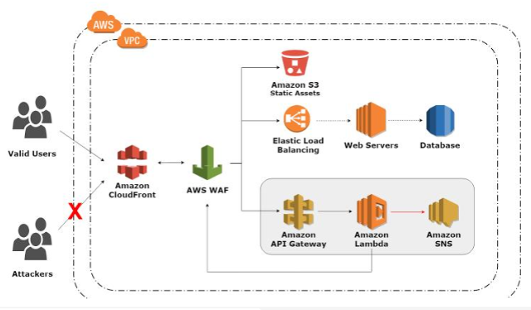

In this project by utilizing CI/CD pipeline, we will build a web application on AWS cloud front.
It will be created using Terraform using Amazon Cloud Front, S3 buckets for static website hosting, and Amazon Cloud Front.
Firstly we will establish AWS resources, web-based security groups, and instances.
Then we will Sett up VPC, Internet gateway, subnets and IAM roles and policies.
A policy for controlling EC2 instances and load balancers is tied to the autos calling services role.
The EC2 instance must be associated to certain target groups of the load balancer.
Elastic load balancer enters the process to manage HTTP requests to the web server,
We will then use code deploy to confirm that the code is deployed on server and codepipeline.

